How to Register for CRA My Business Account
You can sign in or register CRA My Business Account to view and update your business tax information, file and submit returns for many programs, and access your GST/HST, payroll, and corporation income taxes.
- Visit the CRA website. https://www.canada.ca/en/revenue-agency/services/e-services/digital-services-businesses/business-account.html. Or search for “CRA My Business Account”.
- Click on Register for My Business Account if you’re a new user.
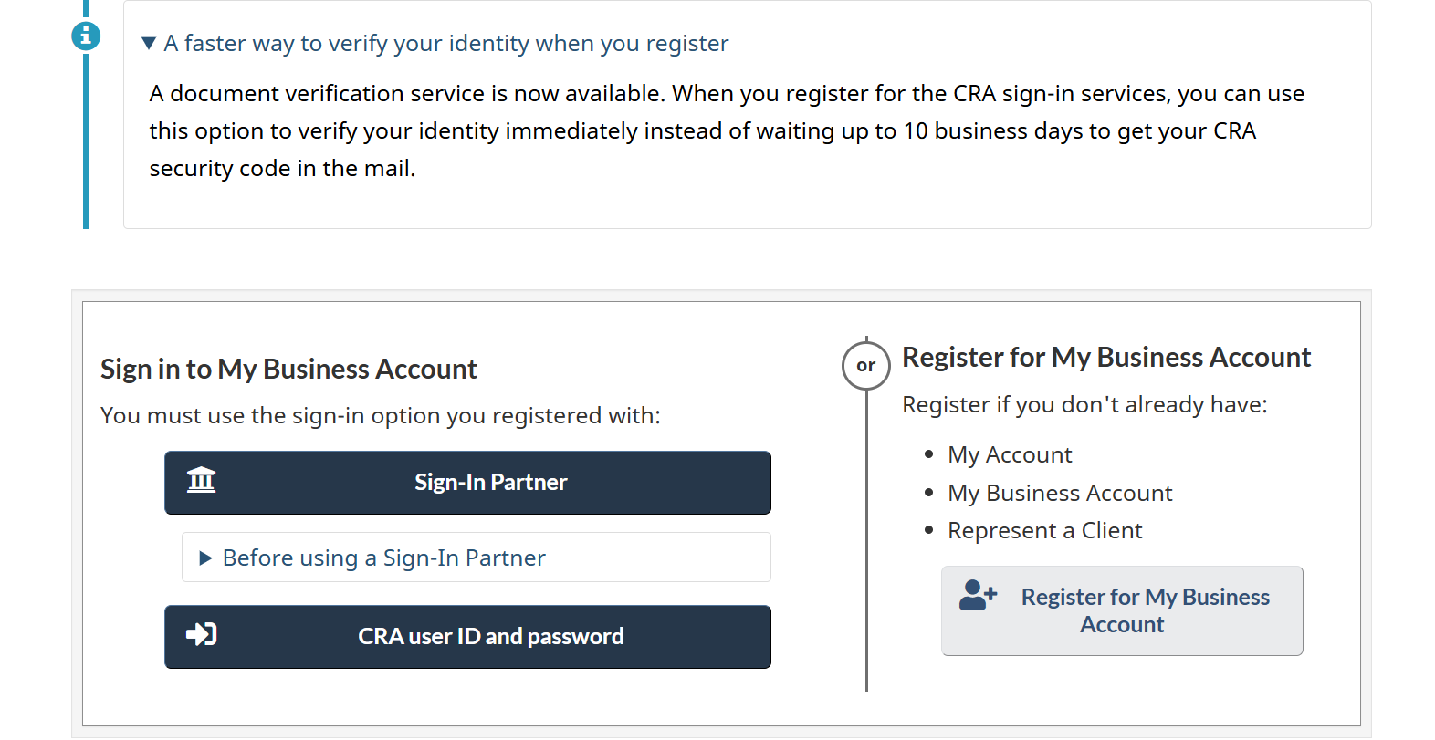
- Follow the prompts to complete all required steps. You will need to provide personal information, such as your Social Insurance Number (SIN) and information from your most recent tax return, as well as your Business Number (BN).
- After completing the initial registration, you will receive a security code by mail within 5–10 business days. This code is required to fully activate your My Business Account.
- Once you receive the security code, return to the CRA My Business Account page and log in using your chosen method to complete activation.
Need Help? For assistance with CRA My Business Account, call CRA at 1-800-959-5525.

