How to register CRA My Account
CRA My Account is an online service provided by the Canada Revenue Agency (CRA) that allows individuals to securely access and manage their tax and benefit information online.
- Visit the CRA website. https://www.canada.ca/en/revenue-agency/services/e-services/digital-services-individuals/account-individuals.html
Or search “CRA My Account for individuals”.
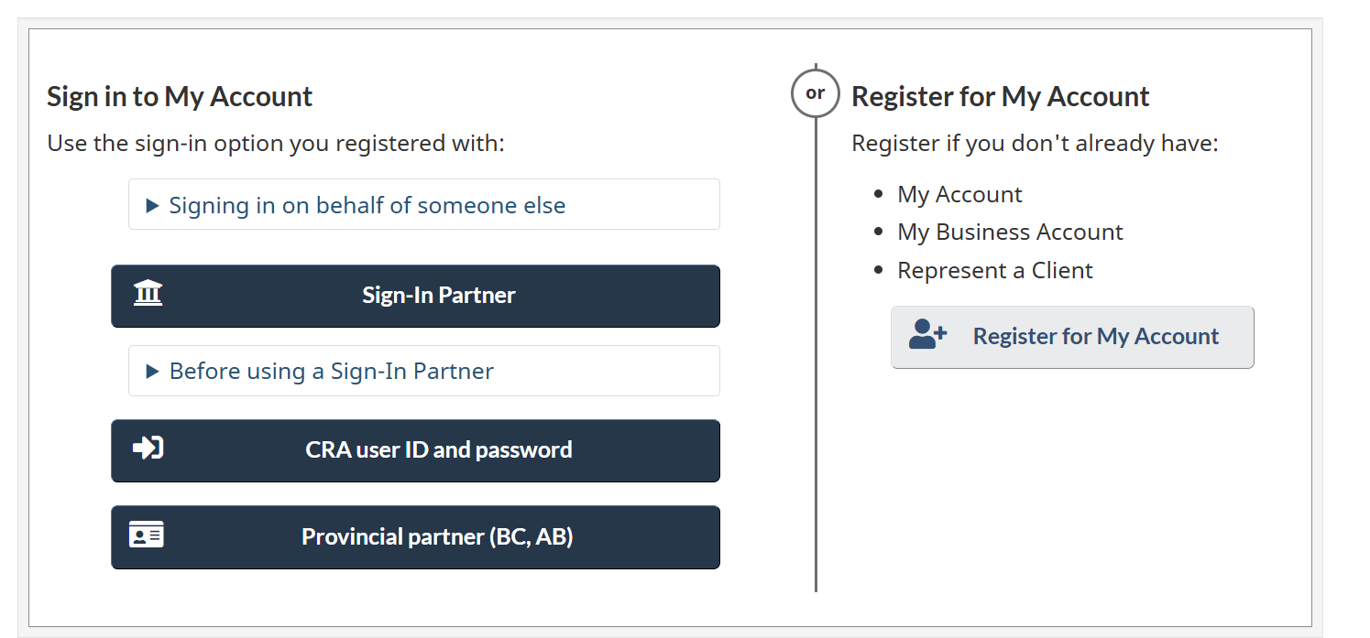
- Click on Register for My Account if you’re a new user.
- Enter personal information (e.g., social insurance number, date of birth, postal code, and the information from your most recent tax return).
- Create a CRA user ID and password.
- Set up security questions.
- After completing initial registration, you will receive a security code by mail within 5–10 business days. This code is required to fully activate your account.
- Once you receive the security code, return to the CRA My Account page and Log in using your chosen method.
Need Help? For assistance with CRA My Account, call CRA at 1-800-959-8281.

