How to Make a Payment to the CRA
You can pay the Canada Revenue Agency (CRA) either online or at your bank.
Paying at Your Bank
If you prefer to pay at a bank branch, the bank may require a CRA payment voucher. If you don’t have one, you can request it by contacting the CRA at 1-800-959-8281 for individual tax and 1-800-959-5525 for business taxes.
Paying Online
Most people choose to pay the CRA online. Follow these steps:
- Go to the CRA Payment Page: Search “CRA My Payment” or use the linkto access the CRA payment page: CRA My Payment.
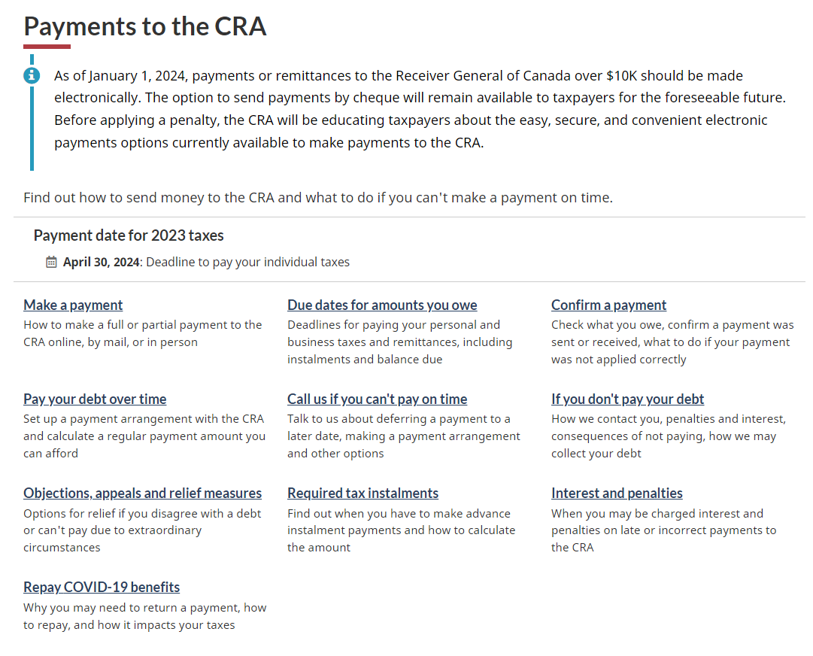
- Choose a Payment Method: Select the payment method you prefer, such as direct bank payment or credit card.
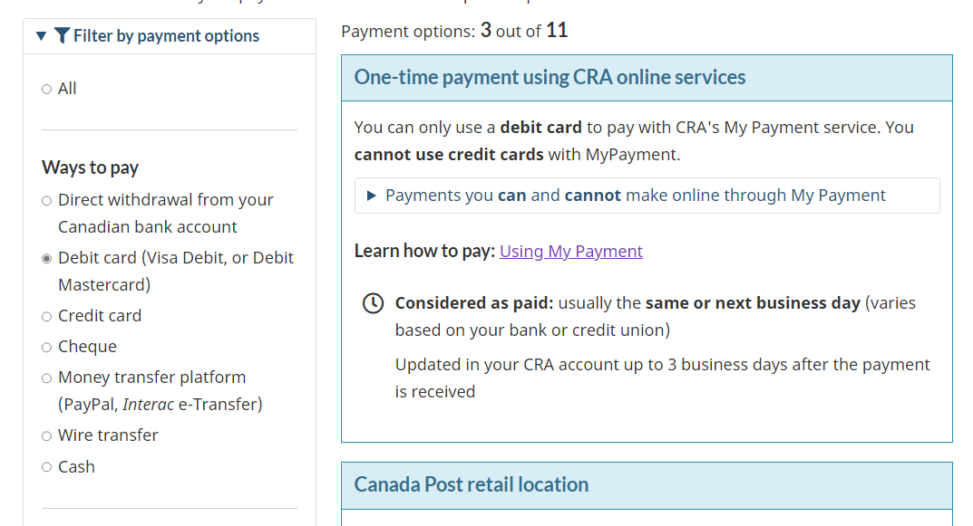
- Select “Pay Now Using My Payment”.
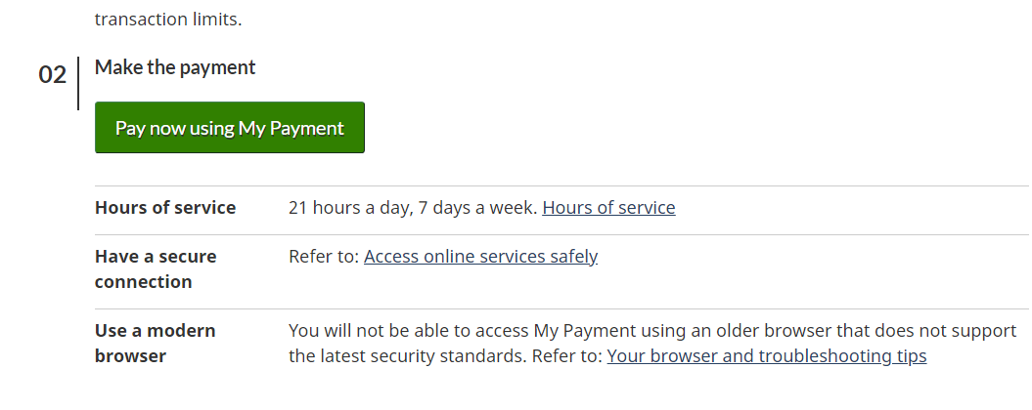
- Choose the Type of Payment:
  - For personal income tax, select “Individual Income Tax (T1)”.
  - For benefit repayments (like GST/HST, Canada Child Benefit, etc.), choose “Benefits and Credits Repayment”. This includes payments for Canada child benefit, GST/HST credit, Canada dental benefit, and others.
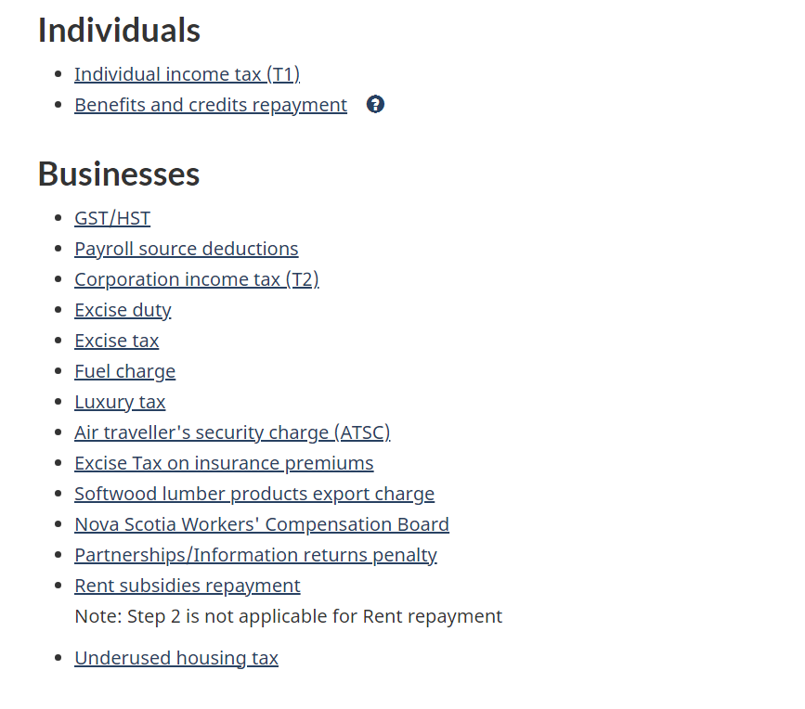
  - For business payments, select the relevant option for your type of business tax.
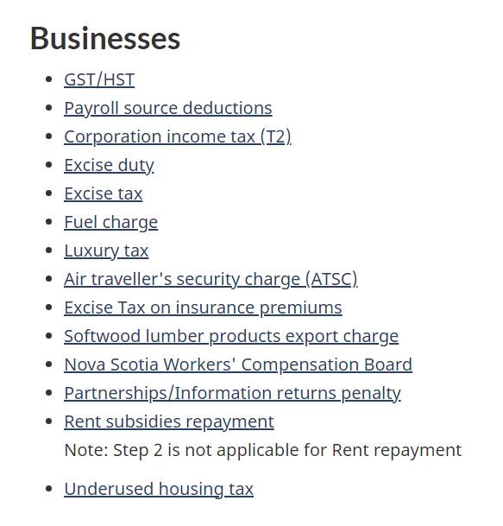
- Enter Your Information: Input your Social Insurance Number (SIN) and the amount you owe. For business, enter the business number.
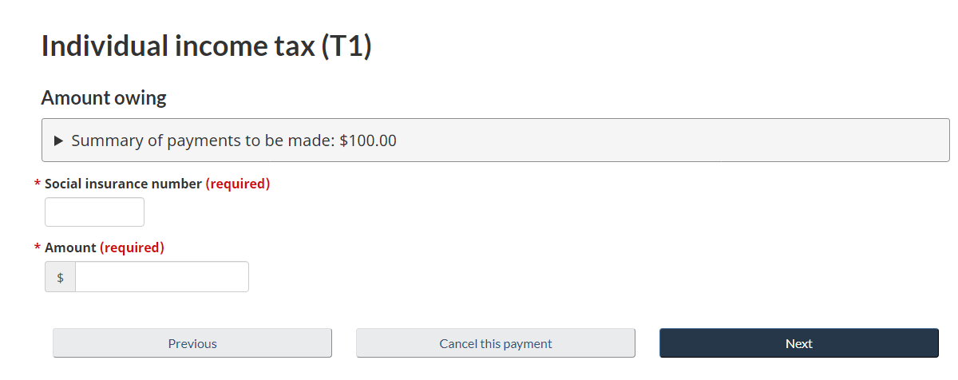
- Enter Your Bank Details and Complete the Payment.

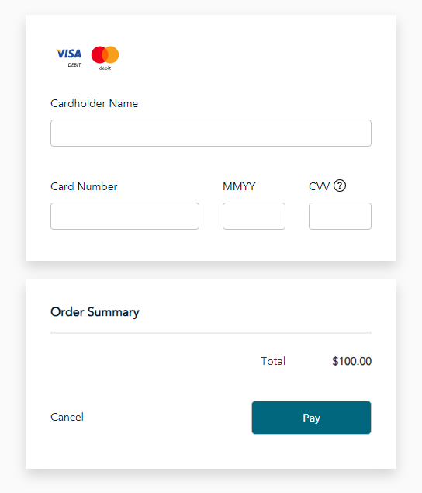
Following these steps will help you easily make a secure payment to the CRA.

