STEP 1: Access your email and find the email we sent you and click “Review and Sign”

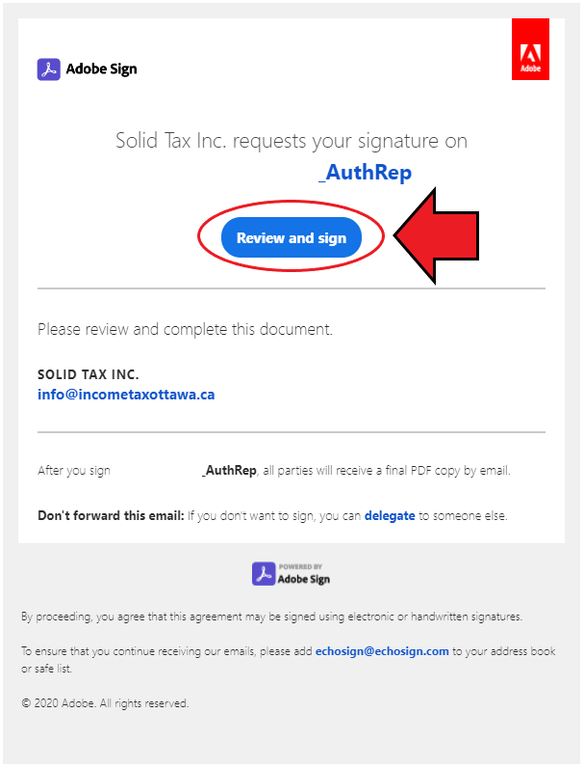

STEP 2: If you have not enabled your cookies from Adobe, please click “Enable all”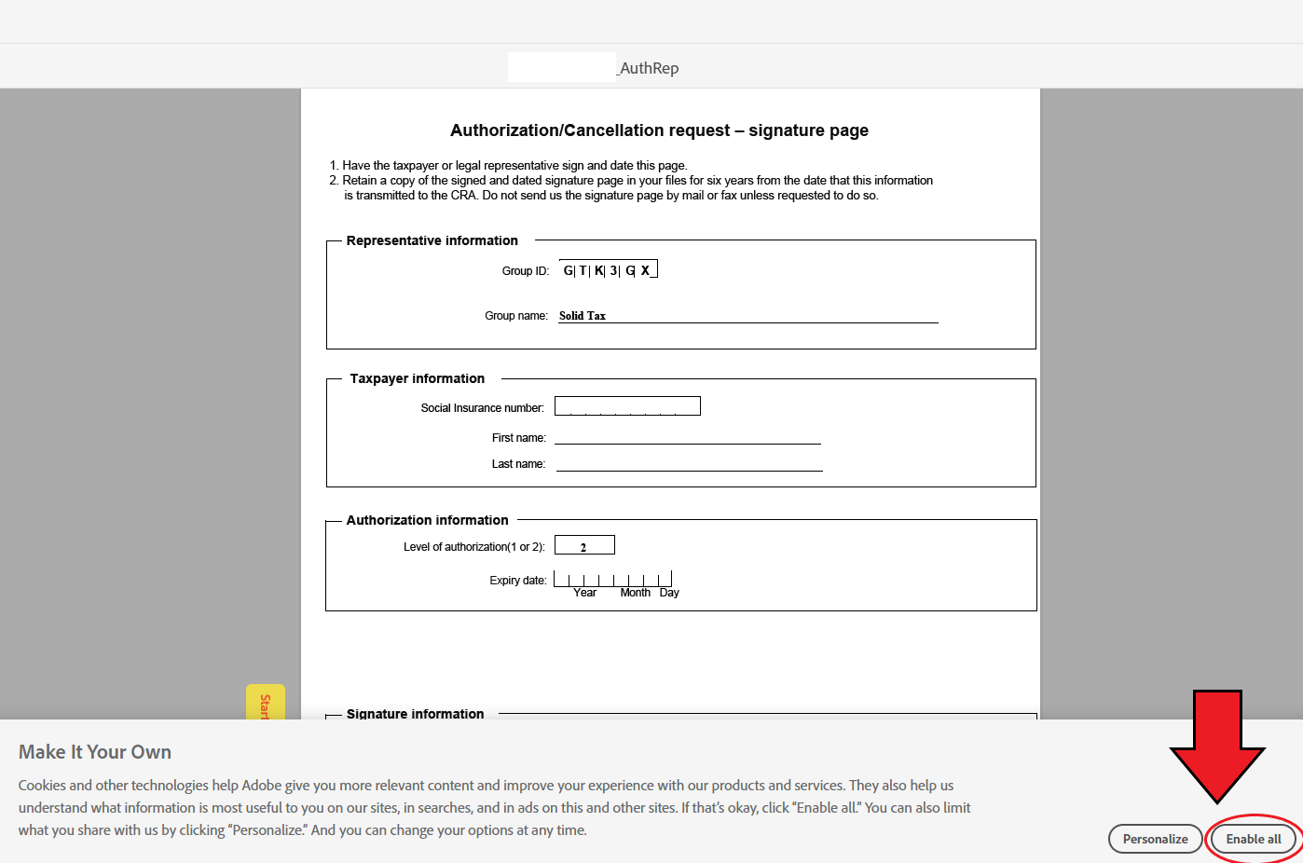

STEP 3: Navigate to where you must sign by following the yellow arrow. Enter your name, choose a method to sign, and click “Apply.”

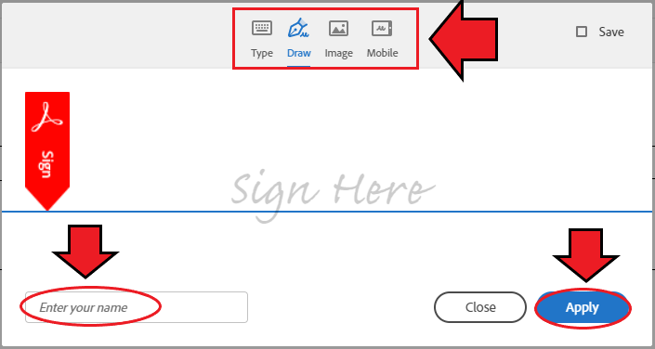

STEP 4: To complete the document, you must click “Click to Sign” at the bottom of the document.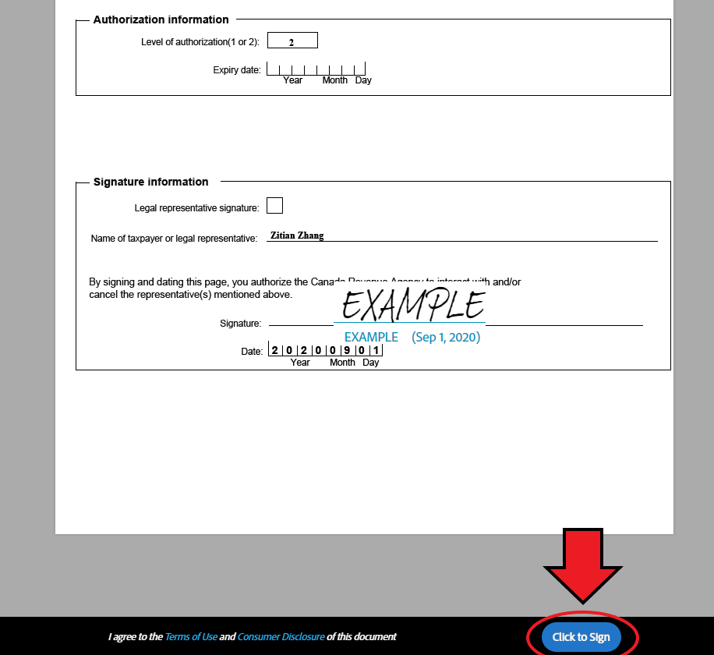

STEP 5: Once you see the following message screen. You’re done!

