Business Authorization Instructions

1. Click on Profile on the top banner



1. On the right hand side you should see something like the picture below if you scroll down

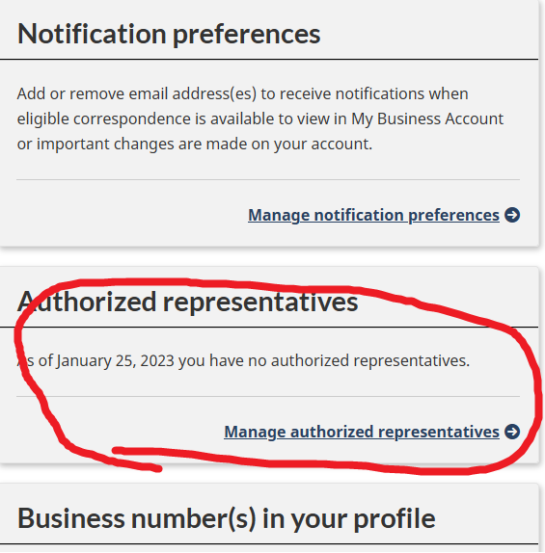

1. Click Manage authorized representatives
2. Click Authorize a representative
3. Group ID: GTK3GX
4. Level 2 authorization
5. No Expiry
6. All accounts
7. Confirm and submit